**Lab practical 03**

**COA**

**Question:**

**Write a program in assembly language to perform subtraction of 8-bit data.**

**Code:**

**org 100h**

**num1 db 24h**

**num2 db 21h**

**start:**

**mov al,num1**

**sub al,num2**

**mov bl,al**

**mov ah,al**

**and ah,0f0h**

**shr ah,4**

**add ah,30h**

**cmp ah,39h**

**jle print_first_digit**

**add ah,7**

**print_first_digit:**

**mov dl,ah**

**mov ah,02h**

**int 21h**

**mov ah,bl**

**and ah,0Fh**

**add ah,30h**

**cmp ah,39h**

**jle print_second_digit**

**add ah,7**

**print_second_digit:**

**mov dl,ah**

**mov ah,02h**

**int 21h**

**mov ah,4Ch**

**int 21h**

**OUTPUT:**

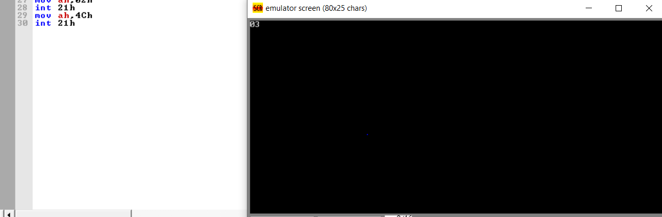

**Question:**

**Write a program in assembly language to perform subtraction of 16-bit data.**

**CODE:**

**org 100h**

**num1 dw 5678h**

**num2 dw 2024h**

**start:**

**mov ax, num1**

**sub ax, num2**

**mov bx, ax**

**mov ah, bh**

**shr ah, 4**

**add ah, 30h**

**cmp ah, 39h**

**jle print_high_nibble**

**add ah, 7**

**print_high_nibble:**

**mov dl, ah**

**mov ah, 02h**

**int 21h**

**mov ah, bh**

**and ah, 0fh**

**add ah, 30h**

**cmp ah, 39h**

**jle print_low_nibble**

**add ah, 7**

**print_low_nibble:**

**mov dl, ah**

**mov ah, 02h**

**int 21h**

**mov ah, bl**

**shr ah, 4**

**add ah, 30h**

**cmp ah, 39h**

**jle print_high_nibble2**

**add ah, 7**

**print_high_nibble2:**

**mov dl, ah**

**mov ah, 02h**

**int 21h**

**mov ah, bl**

**and ah, 0fh**

**add ah, 30h**

**cmp ah, 39h**

**jle print_low_nibble2**

**add ah, 7**

**print_low_nibble2:**

**mov dl, ah**

**mov ah, 02h**

**int 21h**

**mov ah, 4ch**

**int 21h**

**OUTPUT:**

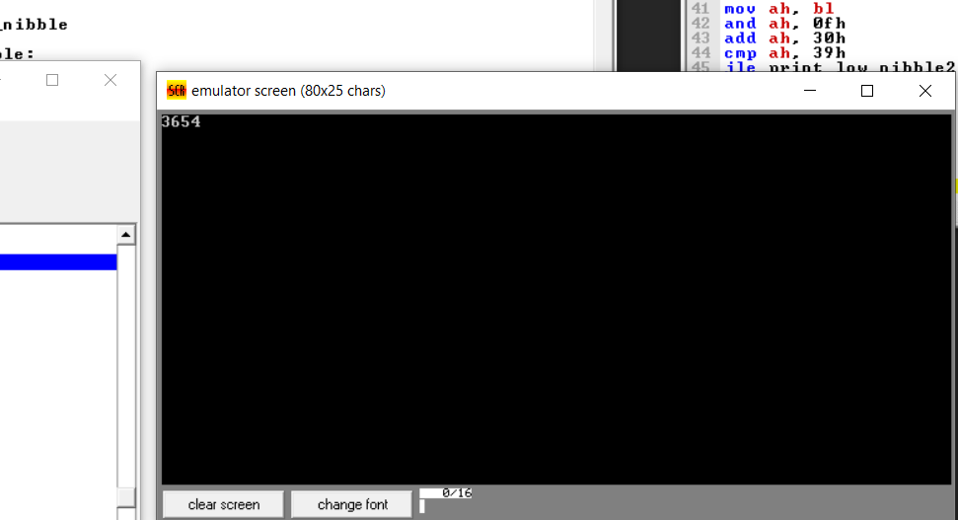

**GITHUB:**